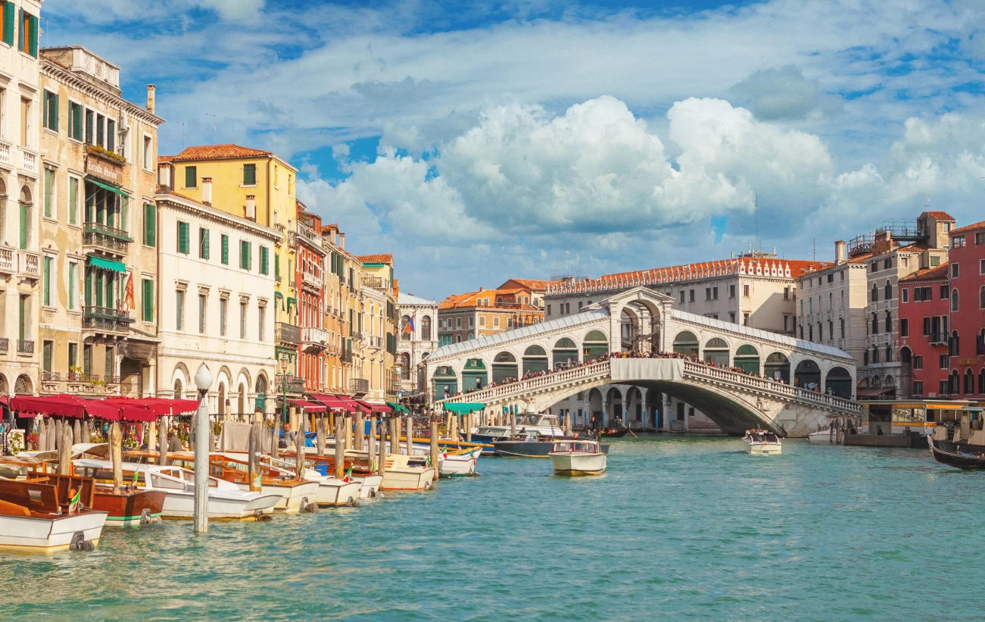
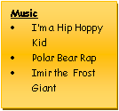
PSHE –
RSE (Relationships and Sex Education) will be taught to both year groups, and Year 6 will have a separate transition project taught to them that is provided to us by the Shropshire Council – ‘respect yourself’. We will look at values such as loyalty and honesty, as well as aspects like changes, puberty and knowing our body.
The rest of the term’s PSHE is centred around health and wellbeing, focusing on the physical and mental sides of ourselves and what can affect them.
Around the World (Italy) - Summer 2025
Computing
Creating media – Introduction to vector graphics

Online Bullying
PE – Monday (Mr Arthur) & Tuesday (Miss Woodhouse). Swimming will be June/July Fridays (Miss Whit)
Knowledge and skills in Physical Education will be developed through Athletics /Rounders / Cricket
Tennis / Hi-5 / Dodgeball
History
Although our topic is geography focused, there will be lots of opportunities to learn about the history of Italy and its differing time periods.

Geography – Around the World – Italy Focus
This term’s topic has more of a geography focus. It will focus on Italy in an Around the World study. Children will build on their existing knowledge of the names of the 7 continents and 5 oceans and the names of a number of countries, as we teach them about location. They will learn where countries in the world are; the location of Italy; The Capoluoghi and about weather and climates around the world, and specifically in Italy. They will also study diversity, looking at biomes, cultures, jobs, buildings and trade links. We will finish the unit by looking at Italian relationships between the people and the land, learning why people settled in certain parts of Italy, and then understanding why it has become a popular tourist destination.

Science – Pupils work scientifically by asking questions, observing systematically, performing practical enquiries, recording, reporting, evaluating and concluding their findings using scientific explanations and evidence which link back to the enquiry focus; analysing the outcomes. Opportunities to gain scientific knowledge and conceptual understanding:
Field Studies
Pupils use sampling techniques to support their studies of living things, using quadrats, sweep nets and other common field studies methods of finding out about animal and plant populations across the year. They compare populations in different areas and discuss the effectiveness of the different techniques they have used.
Heart and Lungs
Pupils study the circulatory system, learning about the basic components that make up blood, how the heart works and how blood circulates round the body. They learn about the lungs and the process of breathing and investigate the effect of exercise on the heart and breathing rates. They learn about the effects of smoking and alcohol.
Music
Mrs Kessel-Fell – Music & KS2 Singing every Wednesday
Mrs Nowotarski - Y5 Violins on Wednesday
Mr Clowes – Percussion Y5 & individual Tuesday
Mathematics – Primarily using White Rose materials; we will be working on: Perimeter, area and volume, Statistics, shape, position and direction, decimals, negative numbers and conversions during Spring Term. We will develop a fluency in maths skills, applying to varying problems through arithmetic, reasoning and problem solving. Children reason mathematically using knowledge-based language and solve relevant problems. Children will complete regular times table practice so that confidence and speed is gained; which is encouraged every week through homework tasks too.
RE – What would Jesus do?
In the first 4 weeks, we will be answering the question ‘What would Jesus do?’ with mini questions per lesson that involve activities such as: identifying features of Gospel texts (for example, teachings, parable, narrative), taking account of the context, suggest meanings of Gospel texts studied, and comparing their ideas with ways in which Christians interpret biblical texts, showing awareness of different interpretations.
What matters most to Humanists and Christians?
Identifying and explaining beliefs about why people are good and bad; making clear connections between Christian and Humanist ideas about being good and how people live.
Art & Design & Technology
• Art – Monet painting of animals and birds
• DT – mechanical systems and CAMS.
English - We follow schemes of work from The Literacy Company: Pathways to Read; Write and Spell, to deliver our English curriculum. This term, pupils will develop spoken language skills to give well-structured descriptions and explanations, as well as written skills to enhance the meaning of purpose of their writing. Written tasks will be linked to personal experiences, experiences of others, real events, poetry and the use of role play. This term the pupils will focus on:
- To write the next chapter of Sky Chasers in the style of the author from two different viewpoints
- write an information leaflet to persuade children to consider the effects of climate change on coral reefs.
- To write a poem about an African animal (which is fun to read out loud!)
Grammar, punctuation & spellings to be integrated throughout & contextualised, plus handwriting.
Through reading in particular, pupils will have a chance to develop culturally, emotionally, intellectually, socially and spiritually. A love of reading is promoted & nurtured through shared and independent reading.

