Monday | Tuesday | Wednesday | Thursday | Friday
8.45am  Reading Pathways   | ******* HOMEWORK IN *******  8.45am – Spelling Hot Test  9am Y5 Percussion / Y6 Maths  9.30am-10:10  Maths whole class  10:10-10:40am  WA hear readers  Worship 10:40 WA | 8.45am – 9:25am  Y5 Violins / Y6 Maths  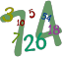 | 8.45am-10:00am  Computing – Mrs Maund   | 8.45am – 9:15pm  Handwriting  
9:45am  Maths  Worship 10:40 KF |  | 9:25-10:10am  Whole Class Maths + Multiplication Check |  | 9:15:10:30am English  
9:45am  Maths  Worship 10:40 KF |  | 10:10-11am  English | 10-11am  English |  | Celebration Assembly 10:30 ZH
11:00-11:15am Break
11.15am  PE (Mr Arthur) | 11.15am  English | 11.15am  Spelling Cold Test    11.45am Y4/5/6 Recorders  Grammar/Spelling/Maths Workshop | 11.15am Maths | 11.15am Maths
LUNCH TIME 12.15-1.00
1-1.45pm Spelling (Pathways)  1:45-2pm Daily Mile  2-3:15pm  PSHE   | 1pm French | 1pm RE   | 1pm-1:30pm  WA hear readers  1:30-1:45pm  Daily Mile  1:45-2:50pm- Science   | 1pm History/Geography  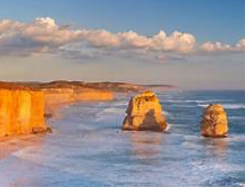  2-2:15pm  Daily Mile
 | 2pm PE | 1.45pm Music – Mrs Kessel-Fell    KS2 Singing  Worship 2:50 HH + CKF
 | Homework handed out |  | Picture News Worship 2:50 KG |  | 2.15pm Art / DT

