Monday | Tuesday | Wednesday | Thursday | Friday
8.45am  Reading Pathways   | ******* HOMEWORK IN *******  8.45am – Spelling Hot Test  9am Percussion / Y6 Maths  9.30am Maths whole class | 8.45am  English | 8.45am  Maths | 8.45am Maths  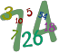
9:45am  Maths + Multiplication Check |  | 9:35 – Y5 Violins / Y6 Maths  10:15 Whole Class Maths | 9:45am English | 9:45am English
9:45am  Maths + Multiplication Check | 10.40am Worship
11:00-11:15am Break
11.15am  PE (Mr Arthur) | 11.15am  English | 11.15am  Spelling Cold Test    11.45am Y4/5/6 Recorders  Grammar/Spelling/Maths Workshop | 11.15am Computing – Mrs Maund   | 11.15am Picture News + Handwriting  
LUNCH TIME 12.15-1.00
1-1.45pm Spelling (Pathways 1)  1.45-2.45pm  PSHE   | 1pm French | 1pm RE   | 1pm Spelling Pathways 2  1:45pm Science   | Celebration Assembly
1pm History/Geography
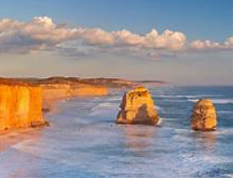

2.00pm Art / DT


 | 2pm PE | 1.45pm Music – Mrs Kessel-Fell    KS2 Singing
2:55 Worship | 2pm PE | 2:55 Worship – Homework handed out | 2:50 Worship

