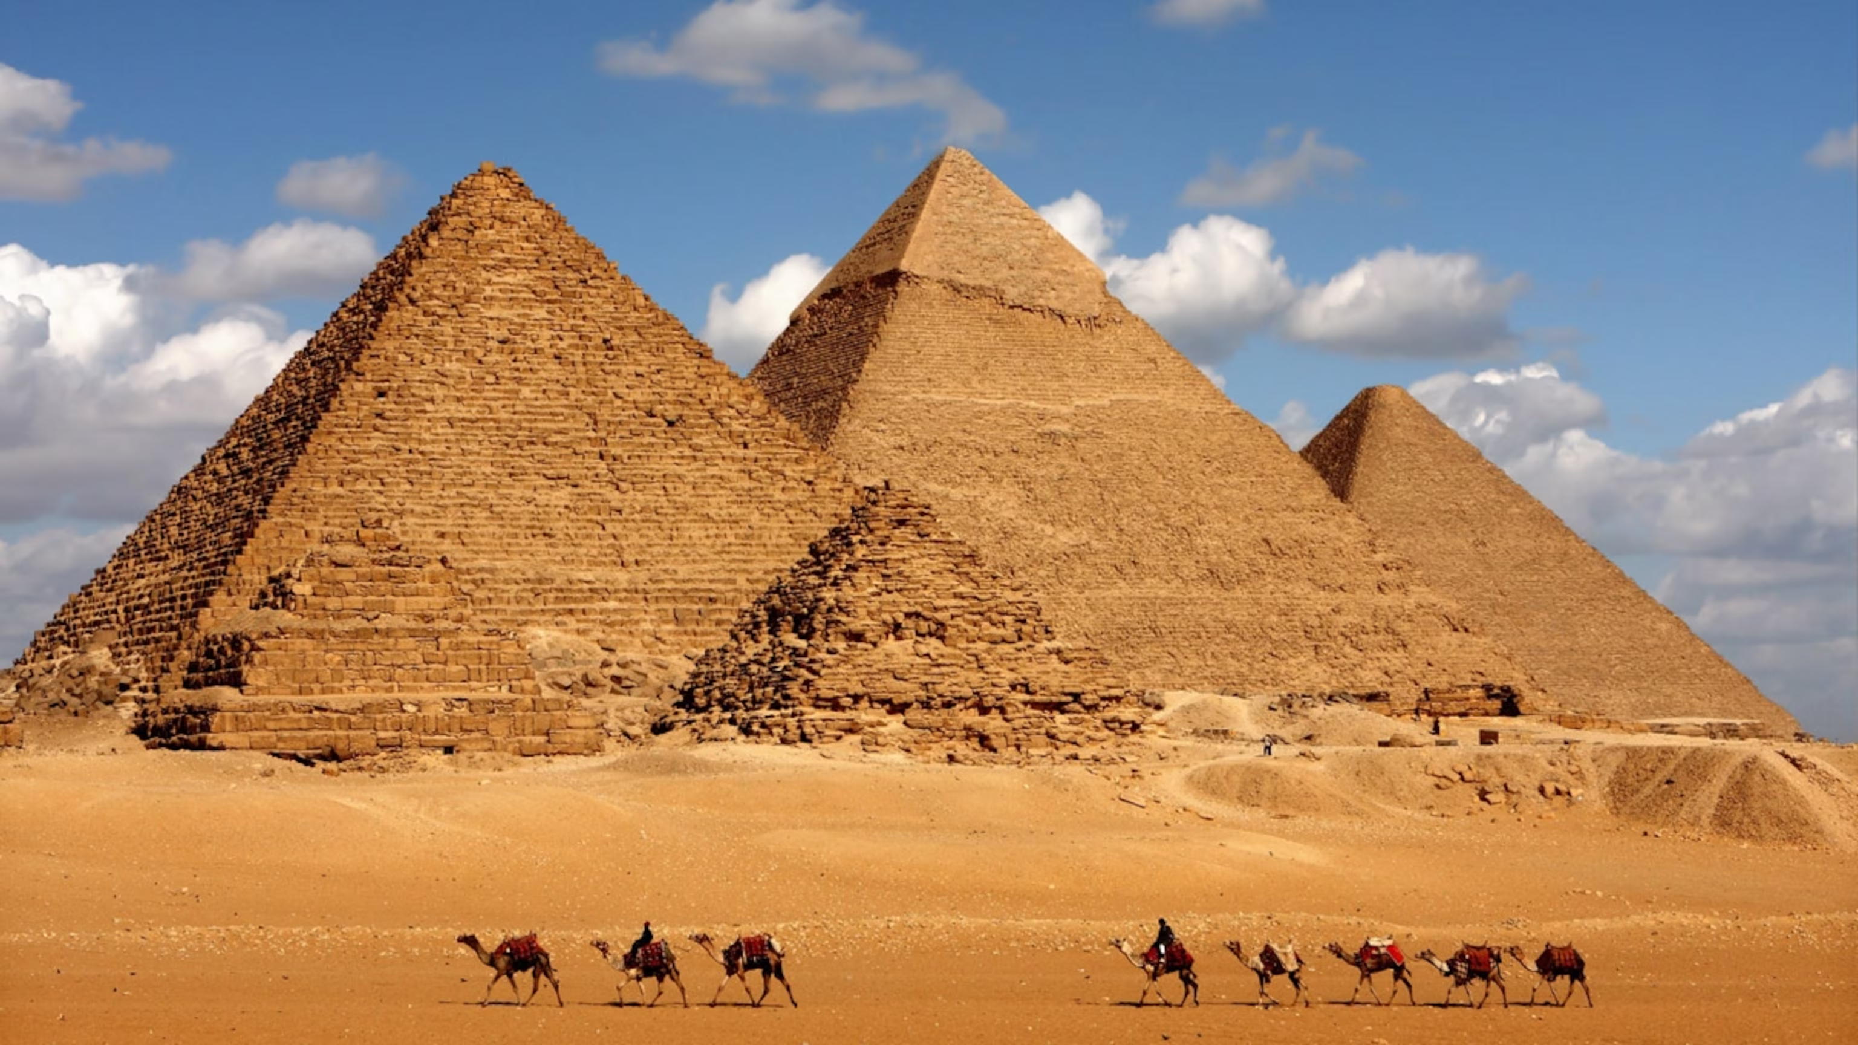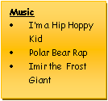
Art & Design & Technology
• Art - Ancient Egypt – sketching, sculptures and clay work.
Giacometti
• DT - Global Food - Celebrating culture and seasonality
Music
Mrs Kessel-Fell – Music & KS2 Singing Wednesday
Mr Butler – guitar Friday
Mrs Nowotarski - Y5 Violins on Wednesday
Mr Clowes – Percussion Y5 & individual Tuesday
RE -
What does it mean to be a Muslim in Britain today?
In Owl class to begin the Autumn term, we will be looking at the religion of Islam, focusing on Muslims’ journey through life, their beliefs in charity and what it looks like to be a Muslim living in modern, current Britain.
Was Jesus the Messiah (incarnation)?
Our 2nd RE unit discusses the idea of incarnation, focusing on the big story of the Bible in Christianity. We will form an understanding of the impact of Jesus on his followers, making connections to current Christian beliefs about Jesus being the Messiah.
PSHE – Relationships + Anti-bullying
This term we will explore the topic of ‘relationships’ using resources from the PSHE Association. This will include families and friendships, where we will learn about civil partnership, romance and marriage, as well as peer influence. We will also discuss safety in relationships, including points such as physical touch, feeling safe, managing pressure and consent in different scenarios. Our work on anti-bullying will focus heavily on the concepts of respect, discrimination, prejudice and expressing opinions.

History
Through cross-curricular links, children will learn about the life of Annie Edson Taylor as well as other famous daredevils in our English unit – Queen of the Falls. We will also learn lots about the fascinating history of Ancient Egypt in our history lessons. This will include understanding of its religion, language, number system and all about the importance of the River Nile.

Mathematics – With support of White Rose Maths materials, we will primarily be working on: Place Value; Addition and Subtraction; Multiplication and Division and Fractions during Autumn Term. We will develop a fluency in maths skills, practising opportunities to apply to varying problems through arithmetic, reasoning and problem solving. Children will reason mathematically using knowledge-based language and solve relevant problems. Children will complete regular multiplication tasks so that confidence in times tables is gained; which is encouraged every week through homework tasks too.
Geography – Ancient Egypt
Whilst this term’s topic is largely history focused, our learning will also focus on both the human and physical geography of Ancient Egypt, and Egypt today.
Children will use maps, atlases, globes and computer mapping to describe key features of the physical aspects of the country. This will include information about rivers and mountains etc. We will also develop an understanding of the human geography of the country, exploring key aspects such as culture, cities and key landmarks.

Computing
Computing systems and networks - Searching

Online relationships

Creating Media – 3D Modelling

PE – Monday & Tuesday
Knowledge and skills in Physical Education will be developed through Dance/Gymnastics / Football, Tag Rugby and Hockey
English - We follow schemes of work from The Literacy Company: Pathways to Read; Write and Spell, to deliver our English curriculum. This term, pupils will develop spoken language skills to give well-structured descriptions and explanations, as well as written skills to enhance the meaning of purpose of their writing. Written tasks will be linked to personal experiences, experiences of others, real events, poetry and the use of role play. This term the pupils will focus on:
- Writing a series of diaries about significant events in Annie Edson Taylor’s life
- Writing their own poem in the style of Berlie Doherty using a range of techniques (metaphors, noun phrases and a refrain)
- Writing a traditional tale focusing on describing settings, characters and an alternative ending -pupils write the story of a character who mistreats others which leads to their own demise.
Grammar, punctuation & spellings to be integrated throughout & contextualised, plus handwriting.
Through reading in particular, pupils will have a chance to develop culturally, emotionally, intellectually, socially and spiritually. A love of reading is promoted & nurtured through shared and independent reading.

Ancient Egypt - Autumn 2024
Science – Pupils work scientifically by asking questions, observing systematically, performing practical enquiries, recording, reporting, evaluating and concluding their findings using scientific explanations and evidence which link back to the enquiry focus; analysing the outcomes. Opportunities to gain scientific knowledge and conceptual understanding:
Classification
Pupils build on their knowledge of classification from previous years, studying the classification of invertebrates and microorganisms in more detail. The children will take part in games and experiments to help them learn about microorganisms and classes of invertebrates, including yeast.

Evolution
Pupils learn about the life and work of Charles Darwin and what is meant by the terms evolution and survival of the fittest. They will learn how animals and plants are adapted to their environment. As a class we will investigate camouflage and find out how humans evolved. The class will carry out a simple experiment to model evolution and selective breeding.

