Monday | Tuesday | Wednesday | Thursday | Friday
8.45am  Reading (independent)  9am  Maths | ******* HOMEWORK IN *******  8.45am – Spelling Hot Test  9am Percussion / Y6 Maths  9.30am Maths whole class  10.00am Reading (Pathways 1)   | 8.45am  Y5 Violins / Y6 Maths  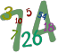  9:25 Maths whole class | 8.45am - Maths  9:30am Reading (Pathways 2) | 8.45am Maths
10am  English  10:40 - Worship |  | 10:00 English | 10:10am English | 9:45am English  10:30 celebration assembly
10am  English  10:40 - Worship | 10.40am Worship
11:00-11:15am Break
11.15am  Art/DT   | 11.15am  English | 11.15am  Spelling Cold Test  11.45am Y4/5 Recorders  Y6 – Maths / Grammar / Spelling Workshop | 11.15am Computing   | 11.15am Topic  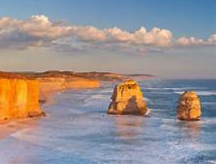
LUNCH TIME 12.15-1.00
1-1.35pm Spelling (Pathways 1)  1.40-2.40pm  PSHE   | 1pm French | 1pm RE   | 1pm Science    2:35 Daily Mile | 1-3:15pm - Swimming
 | 2pm PE | 1.45pm Music – Mrs Kessel-Fell    KS2 Singing |  | 1-3:15pm - Swimming
2:40pm – Picture News | 2pm PE | 2:50 Worship | 2:50 Worship | 1-3:15pm - Swimming

