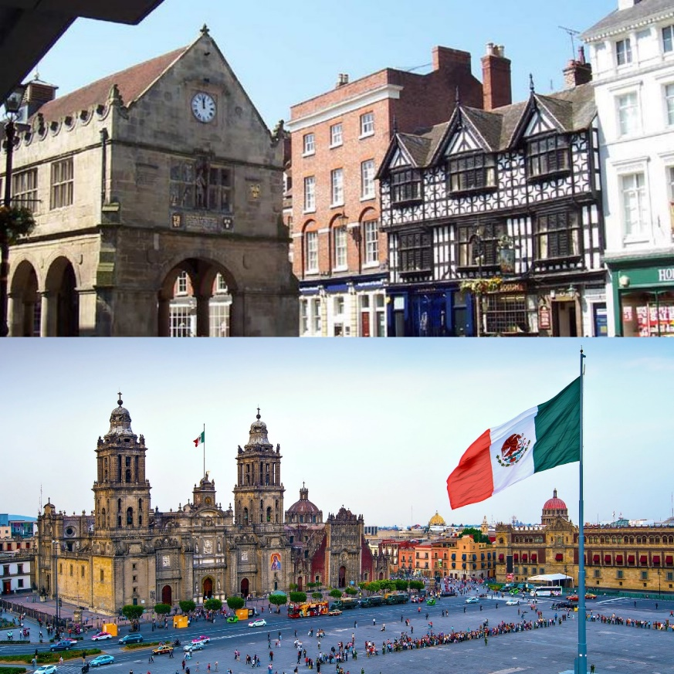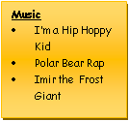

**Shrewsbury vs Mexico City – Summer 2024**

**PSHE**

This term we will explore the topic of ‘health and wellbeing’ using resources from the PSHE Association. This will include healthy sleeping habits, sun safety, personal/online identity, how medicines can contribute to health and how allergies can be managed . We will also focus on Y5/6 Mental health for a focus fortnight. We will use daily news to reflect on current issues in the world. RSE will be part of our summer term, where we will explore human reproduction

and birth, increasing independence and managing transition.

**RE - What kind of king is Jesus? - Kingdom of God**Through exploring the ‘big story’ of the Bible (Genesis), we will make clear connections between belief in the Kingdom of God and how Christians put their beliefs into practice in different ways. Whilst thinking about personal experiences and challenges, children will relate Christian teachings or beliefs about God’s Kingdom to their own lives.

**How does faith help people when life gets hard?**

Children will study the ups and downs of life, focusing on varying religious practices that support people when they are struggling. We will make clear connections between Christian beliefs about God and how they respond to bereavement as well as the big beliefs about what happens when we die, studying the idea of reincarnation.

**History**

Through cross-curricular links children will learn about the lives of famous explorers, and William Shakespeare through our English topics – Bold and Brave Women & Manfish. We will also learn about the fascinating history of Shrewsbury and Mexico City through our topic work.

**Geography – Shrewsbury vs Mexico City**

Our learning will focus on both human and physical geography in this unit, with the aim on answering the question – ‘should I live in Shrewsbury or Mexico City?’.

Children will use maps, atlases, globes and computer mapping to describe key features of the physical aspects of the two cities. This will include climate zones, biomes and vegetation belts, as well as rivers and mountains. We will also develop an understanding of the human geography of the cities, exploring key aspects such as population, culture, famous people and landmarks.

Then the class will use fieldwork to observe, measure, and record human and physical features of Shrewsbury, as well as looking at Mexico city in more depth, to create a balanced argument on which city is better to live in.

**Music**

**Mrs Kessel-Fell** – Music & KS2 Singing Wednesday

**Mr Butler** – guitar Friday

**Mrs Nowotarski** - Y5 Violins on Wednesday

**Mr Clowes** – Percussion Y5 & individual Tuesday

**Art & Design & Technology**

• Hokusai (Great wave, flowers, birds) – colour palette, mixing techniques, range of paints.

• Global Food - Celebrating culture and seasonality

**English -** We follow schemes of work from The Literacy Company: Pathways to Read, Write and Spell, to deliver our English curriculum. This term, pupils will develop spoken language skills to give well-structured descriptions and explanations, as well as written skills to enhance the meaning of purpose of their writing. Written tasks will be linked to personal experiences, experiences of others, real events, poetry and the use of role play. This term will focus on:

* Writing a multi-modal biography of a famous person and how he inspires us.
* Writing a soliloquy in Shakespeare-style.
* Poetry, sonnets
* Debate & presentation (speaking and listening)
* Grammar, punctuation & spellings to be integrated throughout & contextualised, plus handwriting

*Through reading in particular, pupils will have a chance to develop culturally, emotionally, intellectually, socially and spiritually. A love of reading is promoted & nurtured through s*hared and independent reading.

**Computing**

Web page creation

Privacy and Security

Video production

**Mathematics** – With support of White Rose Maths materials, we will primarily be working on: Shape, Position and Direction, Decimals and Conversions of units during Summer Term. We will develop a fluency in maths skills, practising rapid and accurate recall with opportunities to apply to varying problems through arithmetic, reasoning and problem solving. Children will reason mathematically using knowledge-based language and solve relevant problems. Children will complete regular multiplication tasks so confidence in times tables is gained; encouraged every week through homework tasks too.

**PE – Monday & Tuesday**

Knowledge and skills in Physical Education will be developed through Athletics / Rounders / Cricket & Swimming.

**Science** – Pupils work scientifically by asking questions, observing systematically, performing practical enquiries, recording, reporting, evaluating and concluding their findings using scientific explanations and evidence which link back to the enquiry focus; analysing the outcomes. Opportunities to gain scientific knowledge and conceptual understanding:

**Life Cycles**

Pupils revisit the life cycle of plants, and learn about pollination. They compare the life cycles of birds, mammals, insects and amphibians and learn that insects and amphibians undergo metamorphosis.

**Human Development**

Pupils learn about the human life cycle and about the changes of the body during puberty. They learn about the development of a baby during pregnancy and about the birth of a baby. This will match lessons in PSHE on puberty and the feelings associated with growing up.

**Decaying and Recycling**

Pupils learn that decay is an essential aspect of nature; that some materials can be recycled instead of thrown away and that throwing things away has an environmental impact which can be reduced. The children will plan a scientific enquiry to study the process of decaying.