Monday | Tuesday | Wednesday | Thursday | Friday
English    Handwriting / Spellings | ******* HOMEWORK IN *******  Maths  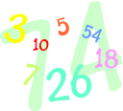 | Y5 Percussion  Reading & Grammar Boost   | Maths | English
PE | Spellings – hot test  Reading | 9.40 Maths | English | RE  
PE | Worship | Worship
Break
Maths | English & cold test | English | KS2 Singing    Reading / Recorders | Maths
LUNCH TIME 12.15-1.05
Reading | PSHE  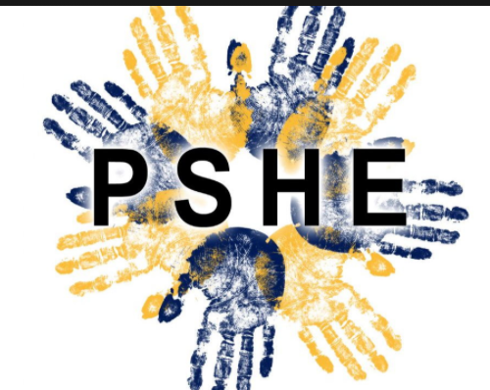 | PE (Miss Ryan) | Computing | Reading
Science   | 1.50pm Y5 Violin – Mrs Nowortarski  2.05pm French   | Topic   | Music – Mr Butler | Art / DT  
Worship |  |  | Worship | Worship

