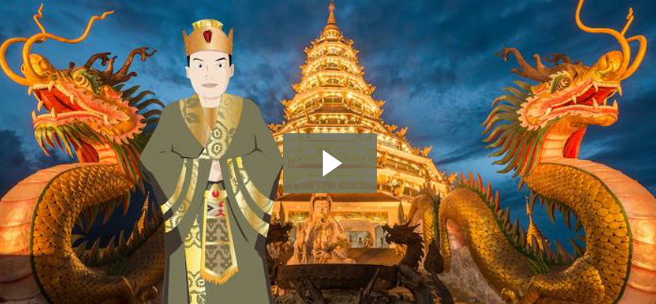
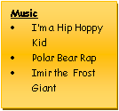
A Taste of Asia
Spring 2022
Mathematics – Pupils will develop a fluency in their maths skills, practising rapid and accurate recall with varied opportunities to apply to problems. Pupils will reason mathematically using mathematical language and solve problems.
Autumn term will primarily focus on these areas:
- Number: multiplication & division - Fractions
- Statistics - Ratio - Measure
- Decimals, percentages & algebra
- Multiplication tables & mental arithmetic
Home support: confident times tables knowledge.
PSHE - Living in a wider world
Learning across the curriculum will cover: protecting the environment; compassion towards others. How information online is targeted; different media types, their role and impact. Identifying job interests and aspirations; what influences career choices; workplace stereotypes. Valuing diversity; challenging discrimination and stereotypes. Evaluating media sources; sharing things online. Influences and attitudes to money; money and financial risks
English - Pupils will develop skills to speak and write fluently to communicate their ideas and emotions. Written tasks are linked to personal experiences, experiences of others, real events, poetry and the use of role play. Through reading in particular, pupils have a chance to develop culturally, emotionally, intellectually, socially and spiritually. A love of reading is promoted & nurtured. This term will focus on:
- Writing narratives
- Explanation texts
- Poetry
- - Classic fiction
- Debate and presentation (speaking and listening)
- Spelling, vocabulary, grammar, punctuation and glossary to be integrated throughout and contextualised
- Shared and independent reading.
- Regular handwriting practise
- Daily spelling revision

Science – Pupils work scientifically by asking questions, observing systematically, performing practical enquiries, recording, reporting, evaluating and concluding their findings using scientific explanations and evidence which link back to the enquiry focus; analysing the outcomes.
Opportunities to gain scientific knowledge and conceptual understanding:
Mixtures & Reactions
After reviewing and extending their knowledge of materials from previous years, pupils study dissolving and learn how to recover materials from a solution. They look at other methods of separating mixtures and carry out an investigation on “sewage” to clean it up before discharge into a river. They investigate chemical reactions including burning and use a key and a series of simple tests to identify some mystery powders. They learn about reversible and irreversible changes and they create a drama about the life of a famous materials scientist.
Beginning of ‘Human Development’ unit (to be continued in summer)
The beginning of this unit will see the children describe the basic changes as humans develop from birth to old age. They will compare the human life cycle to the life cycle of other animals.

Art & Design & Technology
- Global Food (DT) – designing and making Asian recipes
- Asian Art – birds and flowers to include acrylic, charcoal and sculpture
History (The Shang Dynasty)
In this topic children will:
- Undertake an in-depth study of Shang Dynasty of Ancient China. - Develop a chronologically secure knowledge & understanding of British, local and world history, establishing clear narratives
- Understand how our knowledge of the past is constructed from a range of sources.
- distinguish between statements of fact and opinion, retrieve, record and present information from non-fiction.
- address & sometimes devise historically valid questions about change, cause, similarity and difference, and significance.
- Know and understand significant aspects of the history of the wider world: the nature of ancient civilisations;th e expansion and dissolution of empires; characteristic features of past non-European societies. Construct informed responses that involve thoughtful selection and organisation of relevant historical information. •Gain and deploy a historically grounded understanding of abstract terms such as ‘empire’, ‘civilisation’.

- Address and devise historically valid questions about change, cause, similarity and difference, and significance.

Geography - Asia
Locate the world’s countries using maps, concentrating on their environmental regions, key physical and human characteristics, countries, and major cities.
This will focus on China but compare the above aspects to the UK and other countries studied previously.

Music
Mrs Salt will be teaching every Thursday a music lesson plus KS2 Choir. Guitar will continue with Mr Butler on Fridays.
RE
What does it mean if God is holy and loving?
We will explore Bible texts & Christian beliefs about God whilst explore what we can learn by how churches are designed. We will weigh up how biblical ideas about God as holy and loving might make a difference in the world today, developing insights of our own.
What did God do to save human beings?
We will explore Incarnation and Salvation as part of the Bible and what this means to Christians, comparing narratives. Children will understand Holy Communion/Lord’s Supper and weigh up the value and impact of ideas of sacrifice in their own lives and the world today.
PE – Monday & Friday
- Tennis, Hi-5, Dodgeball, Dance & Gymnastics
Computing
Internet Safety, Communication & creating a virtual space

