Wednesday 13th January
L/O: To develop descriptive vocabulary.
Task One:
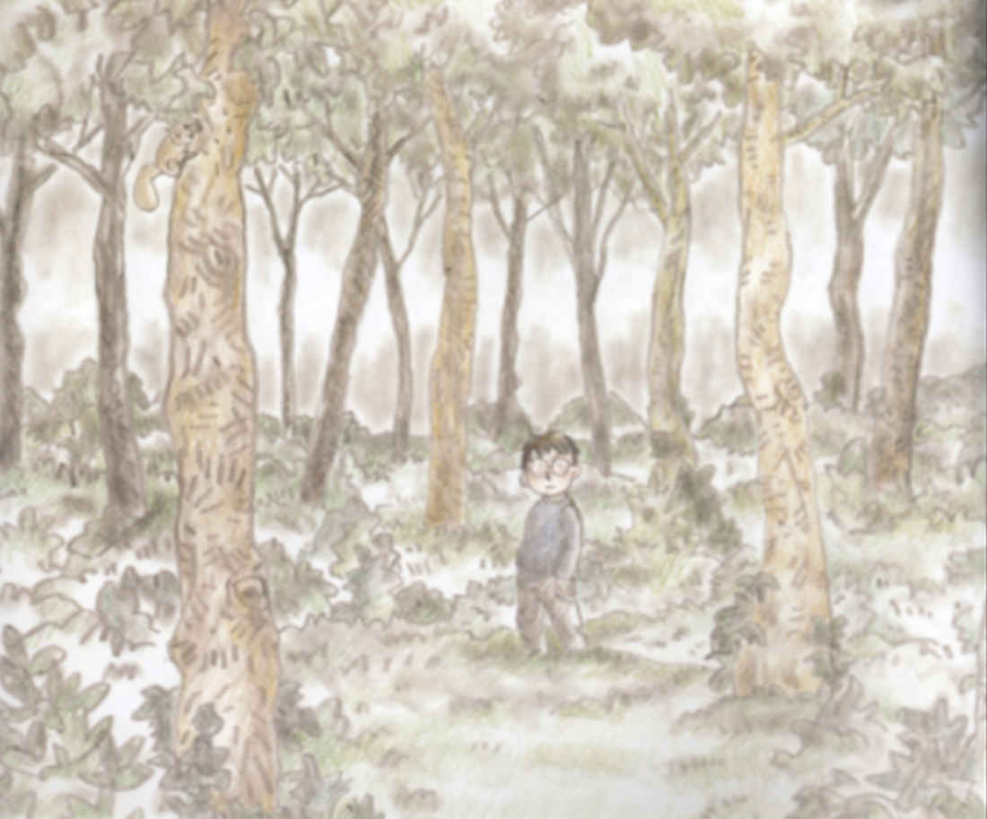
This is how the boy starts his day in the book.
He doesn’t look like he’s having a very exciting day to me!

What might the boy hear?

What might he see?

How might he feel?

What might he be able to smell?

Type your ideas under each question.
Year 4: aim for 3 different answers for each question!

Task 2: Powers of 1, 2 and 3! (Expanded noun phrases)
If you need some help with ‘expanded noun phrases’, here’s a Bitesize help page: https://www.bbc.co.uk/bitesize/topics/zwwp8mn/articles/z3nfw6f

We are going to come up with some snazzy descriptive words and phrases for this setting.
Level One: Can you add effective expanded noun phrases into each box below?
Year 4 – use an online thesaurus to improve your word choices!
towering, coffee-brown trees
a gentle, cool breeze

Task 3 – Year 3 and 4 only (but Year 2 can try it if you want to!)
We now want to use the phrases above to come up with some really good sentences. I’d like your sentences to improve the description using imagery and comparisons. Can you complete my 3 sentence starters below? Add one of your own if you can…

The towering, coffee-brown trees were taller than…

The gentle, cool breeze was quieter than …

The __________ boy felt ___________ than….

