Think about someone or something in your life that you care about...

Is the thing you care about: (highlight one)
- A friend
- A relative
- A pet
- A possession

Explain how you care for what you have chosen (e.g. if it's a pet you would care for it by feeding it)

The diagram below is called a circle of care. I would like you to write in the appropriate circles, things that you care about in your day to day life and also how you show your care.
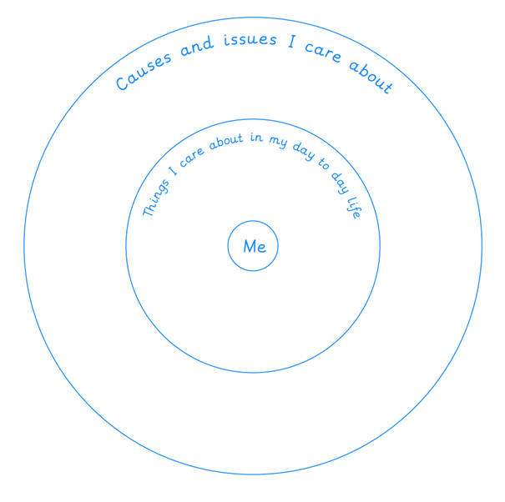

How I show I care?

