Dragonflies – there are four tasks below; ask for help with reading if you need it.

-----------------------------------------------------------------------------------------------------------

1. Read this Bitesize page and watch the video:

What is a force?

2. Now read this website page and play the game!

What are the different forces?

- Task: Can you draw arrows on these diagrams using the 'Draw' tools at the top of the page to show the direction of forces?

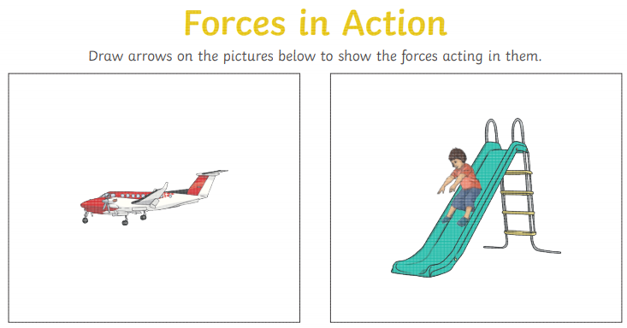

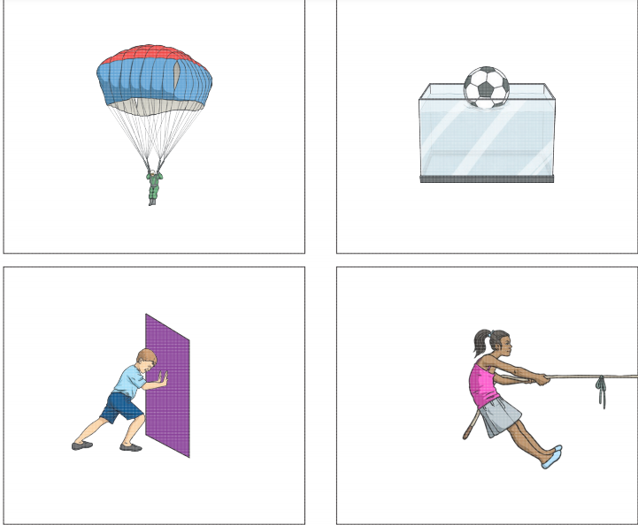

- Finally, my big question for you to answer in your own words:

What is a force? Type your answer below.

A force is....

- Extension task (Year 4 / if you have time):

Where can you find examples of forces in your home? See what you can find to share in our 2.45pm chat!

