Dear Parents, Carers and Children,

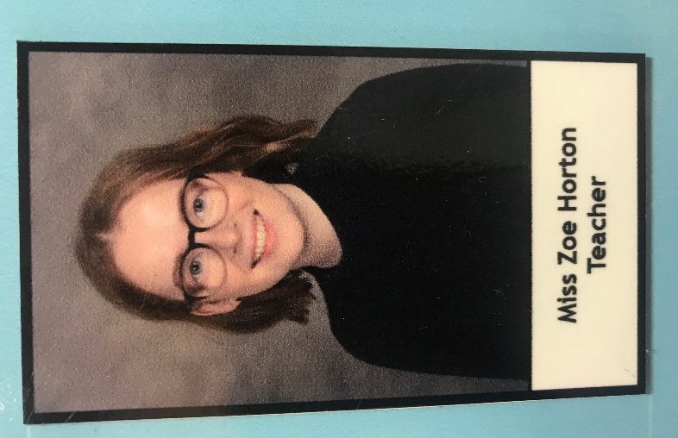
My name is Miss Zoe Horton and I am covering Mrs Farmer’s maternity leave. I have been posting activities on the website for the children and have loved receiving pictures and videos of their work. I did meet the children and we spent a cold morning at Forest School together – it seems a long time ago now but hopefully some of them remember me! I realise it can be a bit daunting meeting somebody new and as I am unable to meet you all at the moment I thought I’d introduce myself so you can get to know me a bit better.

I completed my PGCE and became a qualified teacher in 2018. I have been working within the federation so some of the children may recognise my face from popping over to Ruyton for staff meetings. Before my PGCE, I did an English degree at The University of Cardiff. I thoroughly enjoyed my time in Cardiff and despite studying there for three years I wouldn’t be able to tell you any of the rules for rugby – I just learned to cheer when everyone else was! Some of my friends still live in Cardiff and we enjoy going on walks when we meet up. So far we’ve climbed Pen-Y-Fan, Sugarloaf Mountain and Carn Pica. We tend to bake cakes to take with us as a good incentive to get to the top so we can eat them!

I enjoy playing netball and played throughout school and university. Miss Whit was my coach for a couple of years (she was quite a hard task master!) and we had a lot of fun! If you’ve been reading my posts on the website you’ll see that I’m trying to grow some herbs, vegetables and flowers. I’m not sure I can add gardener to my list of skills just yet but none of them have died so I’m counting that as a success!

I know that Mrs Johnson has spoken to children, parents/carers in year 1 this week. I will be ringing children, parents/carers in reception this week as well. Next time we ring we will be swapping over so I will hopefully get to speak to all of you soon. I understand what a tricky time this is for all of us so if you have any questions, queries or would like to speak to me before I ring you please email admin@ruyton.shropshire.sch.uk to arrange this.

I am really looking forward to being back in school and getting to know you all. The pictures you are sending over do make me smile so if there is anything you would like to share feel free to email them to admin@ruyton.shropshire.sch.uk.

I hope we’re all back together soon.

Kind Regards
Miss Zoe Horton

