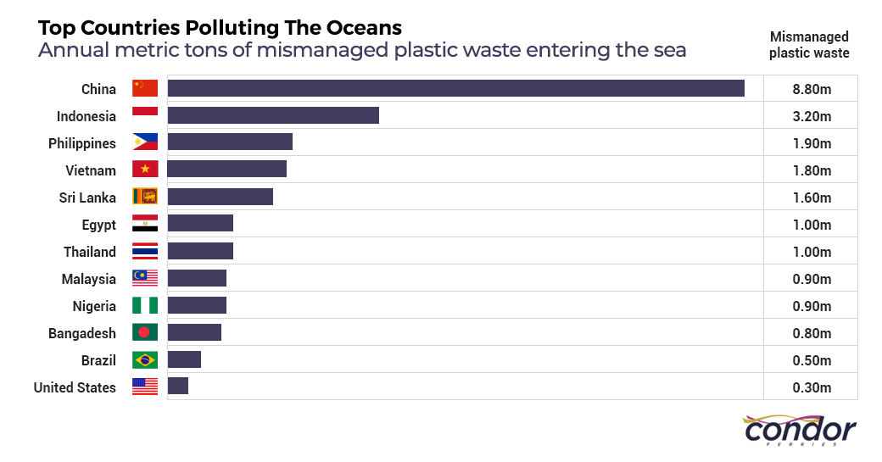What country has the worst amount of plastic waste of all the countries?
What country sends 1.60m of waste to the oceans?
What two countries send 2.00m of waste when you add it together?
What countries send less waste than Thailand?

