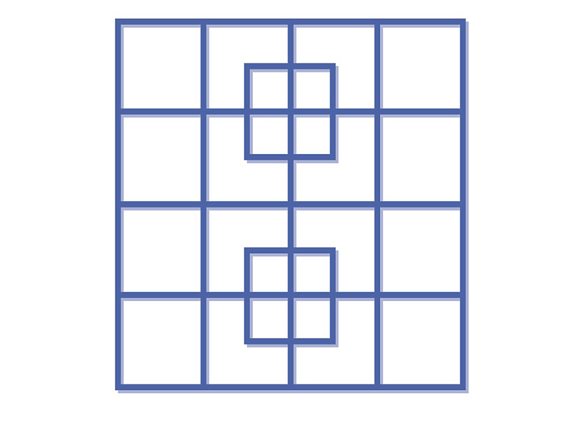
How many squares can you see? Look carefully!

