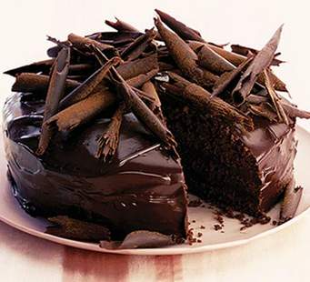
This chocolate cake costs £5.00 to make.
You need to work out how much each piece costs if you can cut 10 slices. Remember you are working in 10ths.

BUT – you need to make some money on this – so can you add 10p to each slice of cake to make a profit?
What is the cost of each slice?

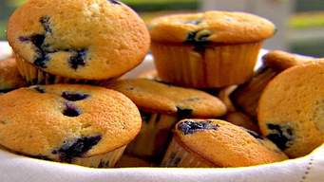
Here are blueberry muffins: It cost you £4.00 to make them all including the cost of the cake case.
There are 8 muffins. How much did each muffin cost to make? (you need to find 8ths – so you are dividing 400 by 8.) (clue – you need to know your 5 x table!)
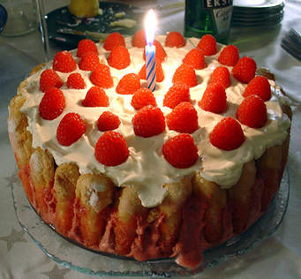
This is a pretty special strawberry cake that has been bought for the price of £10.00.
You need to share this between a family of 10. (easy peasy?)
How much did each slice cost? (Simple?)
How much would you have to spend on cake if you had 40 people coming to the party? (hint – you need to buy more cakes)

Some good brain teasers there for you.
Cake 1 – the chocolate cake – it cost £5.00 – which is 500 pence.
You divided it between 10 people – so you move the number over one place so 500 becomes 50
So each piece cost 50p
But to make a profit – you must add 10p to each slice – so 50p and 10p equals 60p

Cake 2 – the muffins – you have 8 muffins and they cost £4.00 to make
Dividing 400 by 8 is tricky – unless you know that 8 x 5 = 40
If I divide 40 by 8 (I have divided the 400 by 10 and got 40)
400 divided by 10 = 40 40 divided by 8 = 5 BUT (you must remember to multiply by 10 at the end as you divided by 10 at the beginning)
5 x 10 = 50
Are you lost? what I the 50? it is 50p

Cake 3 – this is easy – it cost £10.00 – you divide it by 10 people so each slice costs you £1.00
10 divided by 10 = 1
BUT – what if you need to feed 40 people
Well 1 cake feeds 10 people so 40 is 10 x 4
if 1 cake costs £10.00 you would say 4 cakes would cost 4 x the £10 – which is £40.00

I hope you enjoyed the task!

