The boys who cried “robber!”
By Dominic Berry

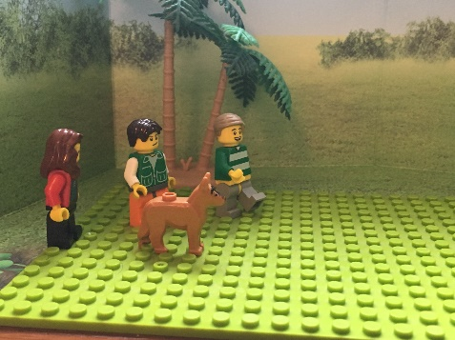  The boys and mum went with Tilly, the dog, to the park. | 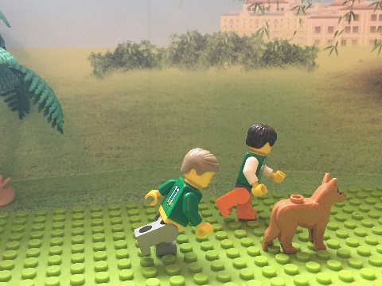  ‘Come on Tilly’, John shouted, ‘Let’s go play!’ | 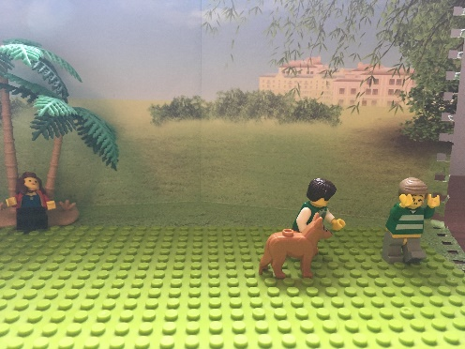  The boys played with Tilly while mum went for a snooze by a tree.
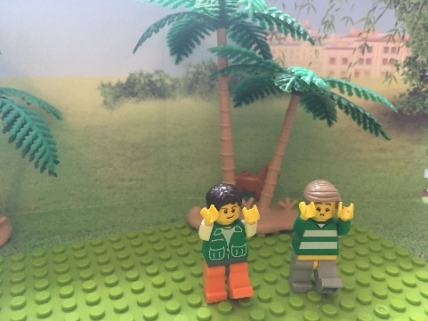  Tilly ran behind a tree. Sniggering, the boys cried ‘Mum, mum, a robber has taken the dog!’ | 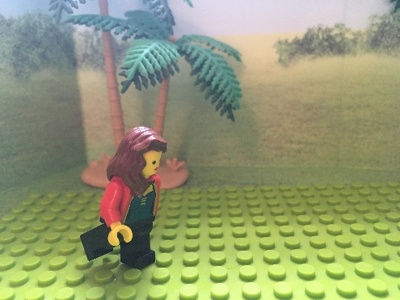  Terrified, Mum sprinted over to John and Garry. | 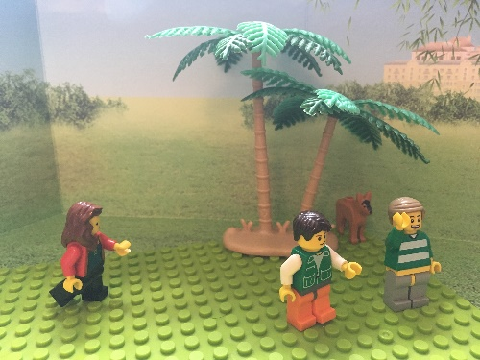  ‘The dog is behind the tree! That wasn’t funny boys.”
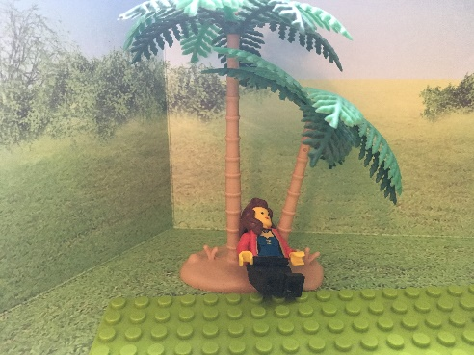  Angrily, Mum grumbled and went back for her snooze. | 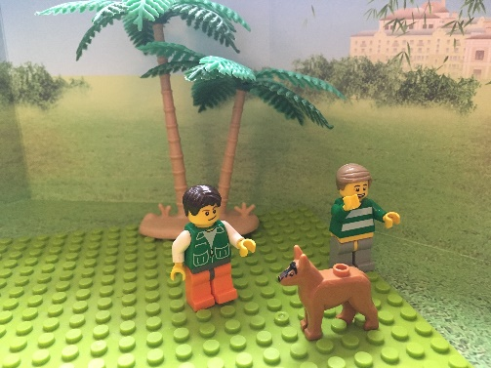  The boys continued to play with Tilly. | 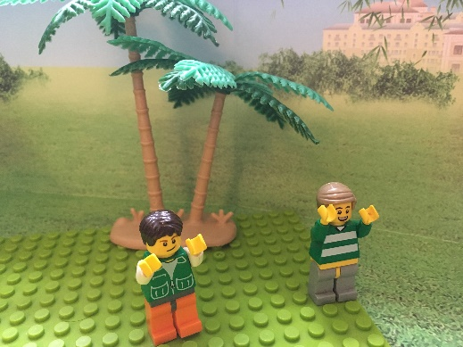  Tilly ran off again!
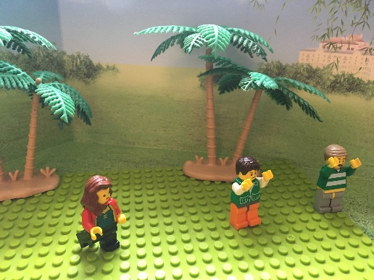  Mischievously, the boys shouted “A robber nicked the dog mum!” Mum came running again. | 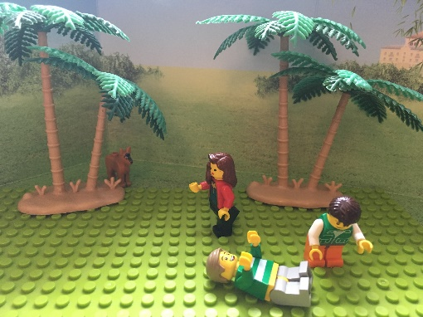  Garry and John fell over laughing while mum said “Stop being silly, the dog is behind a tree.” | 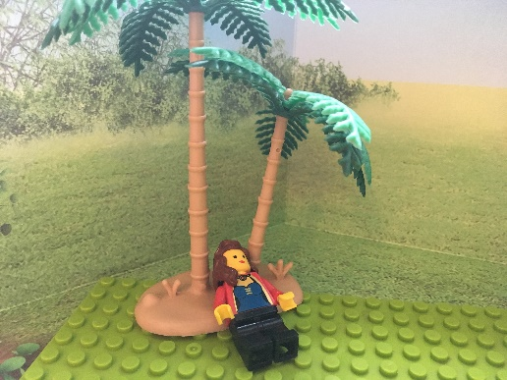  She went back a second time for her snooze.
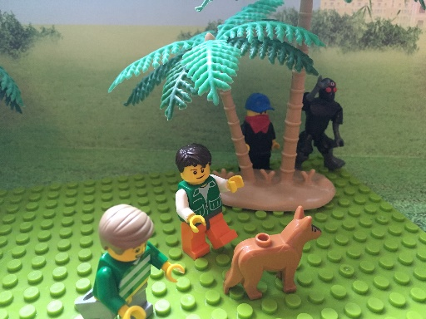  The kids carried on playing and didn’t notice some robbers behind a tree. | 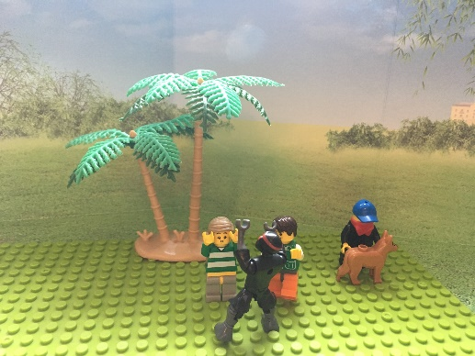  Then, the robbers jumped out one distracted them while the other took the dog! | 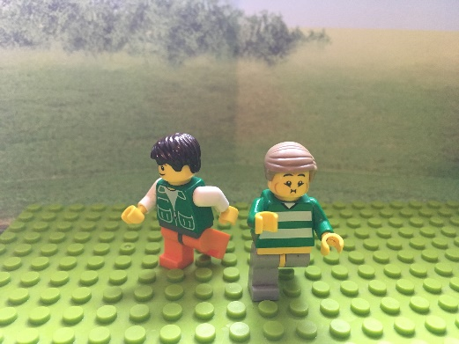  “Where’s Tilly?” asked Garry. “I don’t know,” cried John.
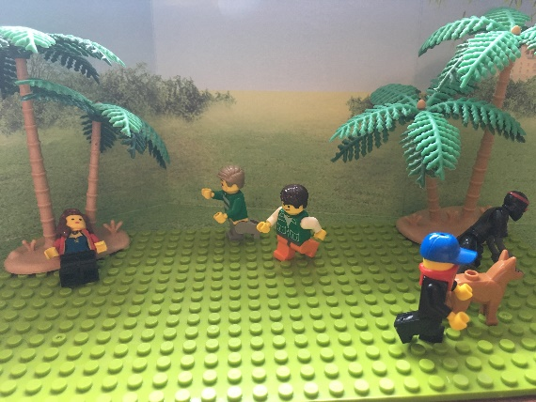  The boys ran back to mum and yelled “Robbers stole the dog for real!” | 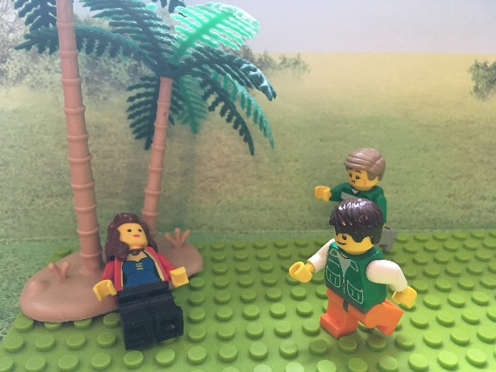  But mum kept on sleeping, she didn’t believe them, she thought it was another joke. | 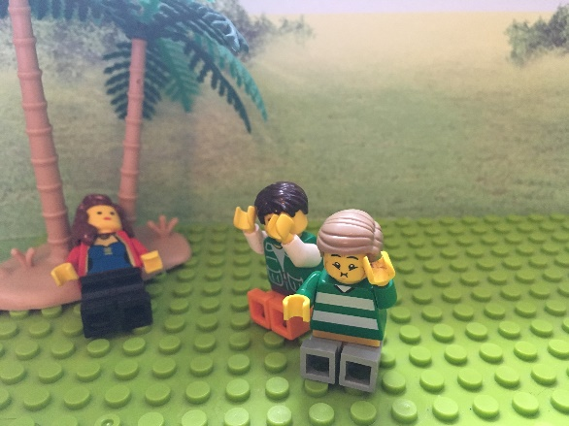  The boys collapsed in disbelief and started to cry!

The End
This parable teaches us not to pretend we need help when we don’t, because if you pretend too many times people might not believe you when you really do need help.

