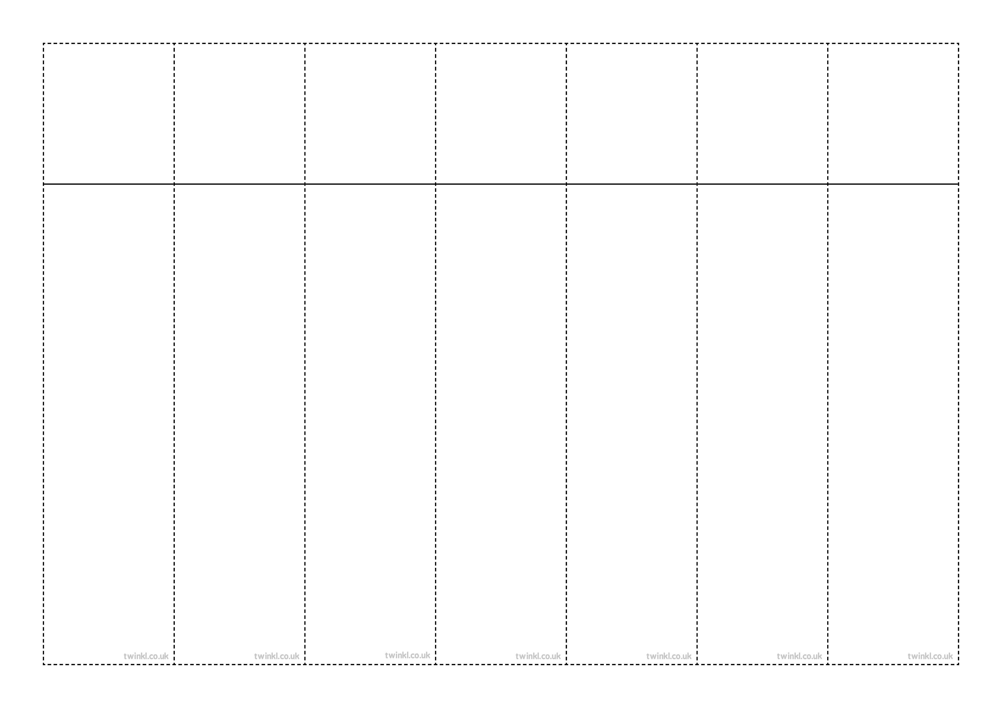
Week 4
Using an apostrophe to mark where a letter is missing
(contractions)
can’t
didn’t
hasn’t
couldn’t
it’s
wouldn’t
shouldn’t
wasn’t
Mr
Mrs
Week 4
Using an apostrophe to mark where a letter is missing
(contractions)
can’t
didn’t
hasn’t
couldn’t
it’s
wouldn’t
shouldn’t
wasn’t
Mr
Mrs

Week 4
Using an apostrophe to mark where a letter is missing
(contractions)
can’t
didn’t
hasn’t
couldn’t
it’s
wouldn’t
shouldn’t
wasn’t
Mr
Mrs

Week 4
Using an apostrophe to mark where a letter is missing
(contractions)
can’t
didn’t
hasn’t
couldn’t
it’s
wouldn’t
shouldn’t
wasn’t
Mr
Mrs

Week 4
Using an apostrophe to mark where a letter is missing
(contractions)
can’t
didn’t
hasn’t
couldn’t
it’s
wouldn’t
shouldn’t
wasn’t
Mr
Mrs

Week 4
Using an apostrophe to mark where a letter is missing
(contractions)
can’t
didn’t
hasn’t
couldn’t
it’s
wouldn’t
shouldn’t
wasn’t
Mr
Mrs

Week 4
Using an apostrophe to mark where a letter is missing
(contractions)
can’t
didn’t
hasn’t
couldn’t
it’s
wouldn’t
shouldn’t
wasn’t
Mr
Mrs

