Myths and Legends of the Alaskan Eskimo

The Eskimo
Alaska has always been a very active area for volcanoes. Located right on the ring of fire there are many historically active volcanoes. There are also 40 active volcanoes that occur in the state, mostly in the Kodiak and Aleutian Islands. Alaskan volcano legends are primarily Eskimo in origin. Eskimo is a term for the people that are the native inhabitants of the Artic regions of Alaska, Greenland, Siberia, Nunavut, Quebec, and the Northwest Territories. These people are divided into two groups the Inuit and the Yupik. The Inuit live in the northern part of Alaska and speak Inuktitut; the Yupik people live in the western part of Alaska and speak Yup'ik. While these two groups share some similarities in language and region they have different ways of life and culture.
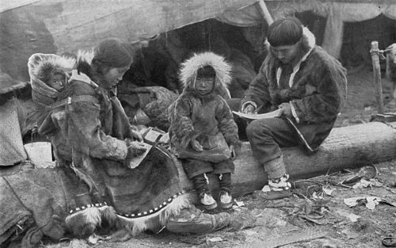

An Eskimo Family

The Legends of Old Willie
For many generations legends were passed down through oral history, or storytelling. This legend tells of the cloud coming across the sky just as the summer season was about to begin..
A grandmother and granddaughter named Nasaruhk and Paniruhk. They were alone in a small house with no one to hunt for them. The other villagers were kind though and took pity on them giving them meat and fish. The grandmother saved as much food as she could for the winter by drying the meat and preserving it in skin bags filled with seal oil. The grandmother and daughter also picked as many plants and fruits as they could in the summer too and saved them for the long winters. However as summer was coming the warm weather was swept away by a cloud from the north. With the cold cloud no one came to visit them anymore and the grandmother and daughter survived on what they had saved.
Legends also tell of two other villagers who survived the summer that did not come. The two, a mother and small son traveled two hundred and fifteen miles through the cold with no food to reach another village that had food to offer.
The summer that never came was due to the huge plumes of volcanic ash and smoke that covered the sun for many months.

