Name: Date:
Read the following story carefully.
Kylie’s day at the farm
Kylie had never been out of town or to a farm. She thought farm animals were cartoons made up for children’s stories. Of course, she knew about cats and dogs but she had never seen a real sheep or bull! |  | 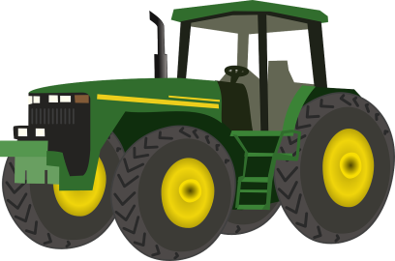
Kylie had seen a horse, of course, because her friend went riding once a week and she sometimes went with her.
She was amazed to learn that her morning eggs came from hens and that ducks were not all called Donald! Kylie could not believe that her mum allowed her to eat bacon from a pig or even to drink milk from a cow.
Her favourite farm animal was the little playful goat that answered to his name. Kylie did think it strange that the baby goat was called a ‘kid’ and that it drank from a baby’s bottle!
Kylie loved her day but came away confused – she still had so much to learn about the farm animals.
Draw a picture to illustrate the story.

Answer the following questions.
- How many times had Kylie visited a farm?

- What did Kylie think about hens laying eggs?

- When had Kylie seen a horse before?

- What was strange about the goat?

- Which was Kylie’s favourite animal?

- What name did Kylie think all ducks were called?

- Where did Kylie learn that bacon and milk came from?

- What is a baby goat called?

- Have you ever been to a farm?

- Write a sentence about your experience of farms.

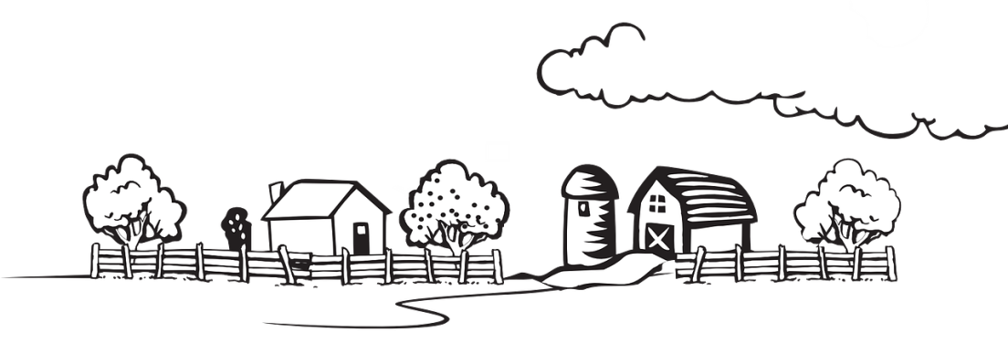

Answers
      - Kylie had never visited a farm before.
      - Kylie couldn’t believe hens laid eggs and that this is how she got her morning egg.
      - Kylie had seen a horse before when she went riding with her friend.
      - She thought it strange that the goat drank from a baby’s bottle.
      - Kylie’s favourite animal was the goat.
      - Kylie thought all ducks were called Donald.
      - Kylie learnt that bacon came from pigs and that milk came from cows.
      - A baby goat is called a kid.
      - Accept different responses.
      - Accept different responses.

